Contents
Figure S1-S2: Skylark HWE 2
Figure S3: Linkage decay 4
Figure S4: Estimation of GERP scores 5
Figure S5-S7 Demographic inferences 6
Figure S8-S9 Functional genotype probability 9
Figure S10-11 Z loss-of-function allele probability 10
Figure S12-13 W guarding probability 11

Figure S1-S2: Skylark HWE
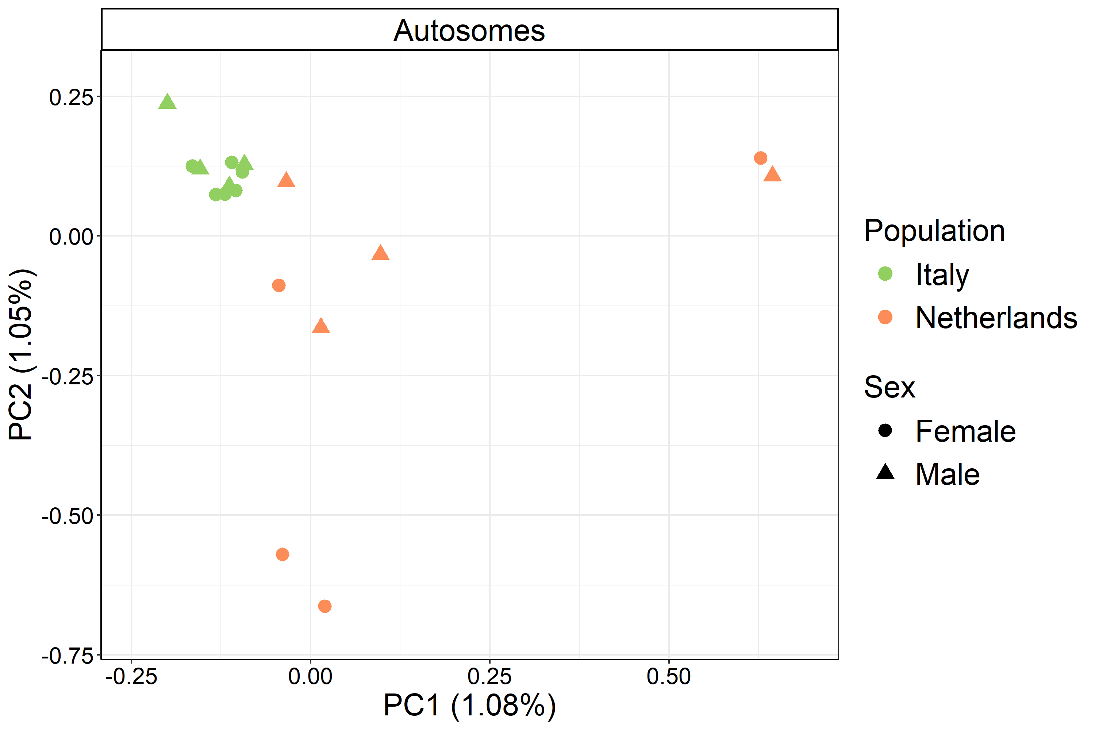
Figure S1 Principal components 1 and 2 of skylark individuals, based on biallelic SNPs from autosomes with a minor allele count of 2.
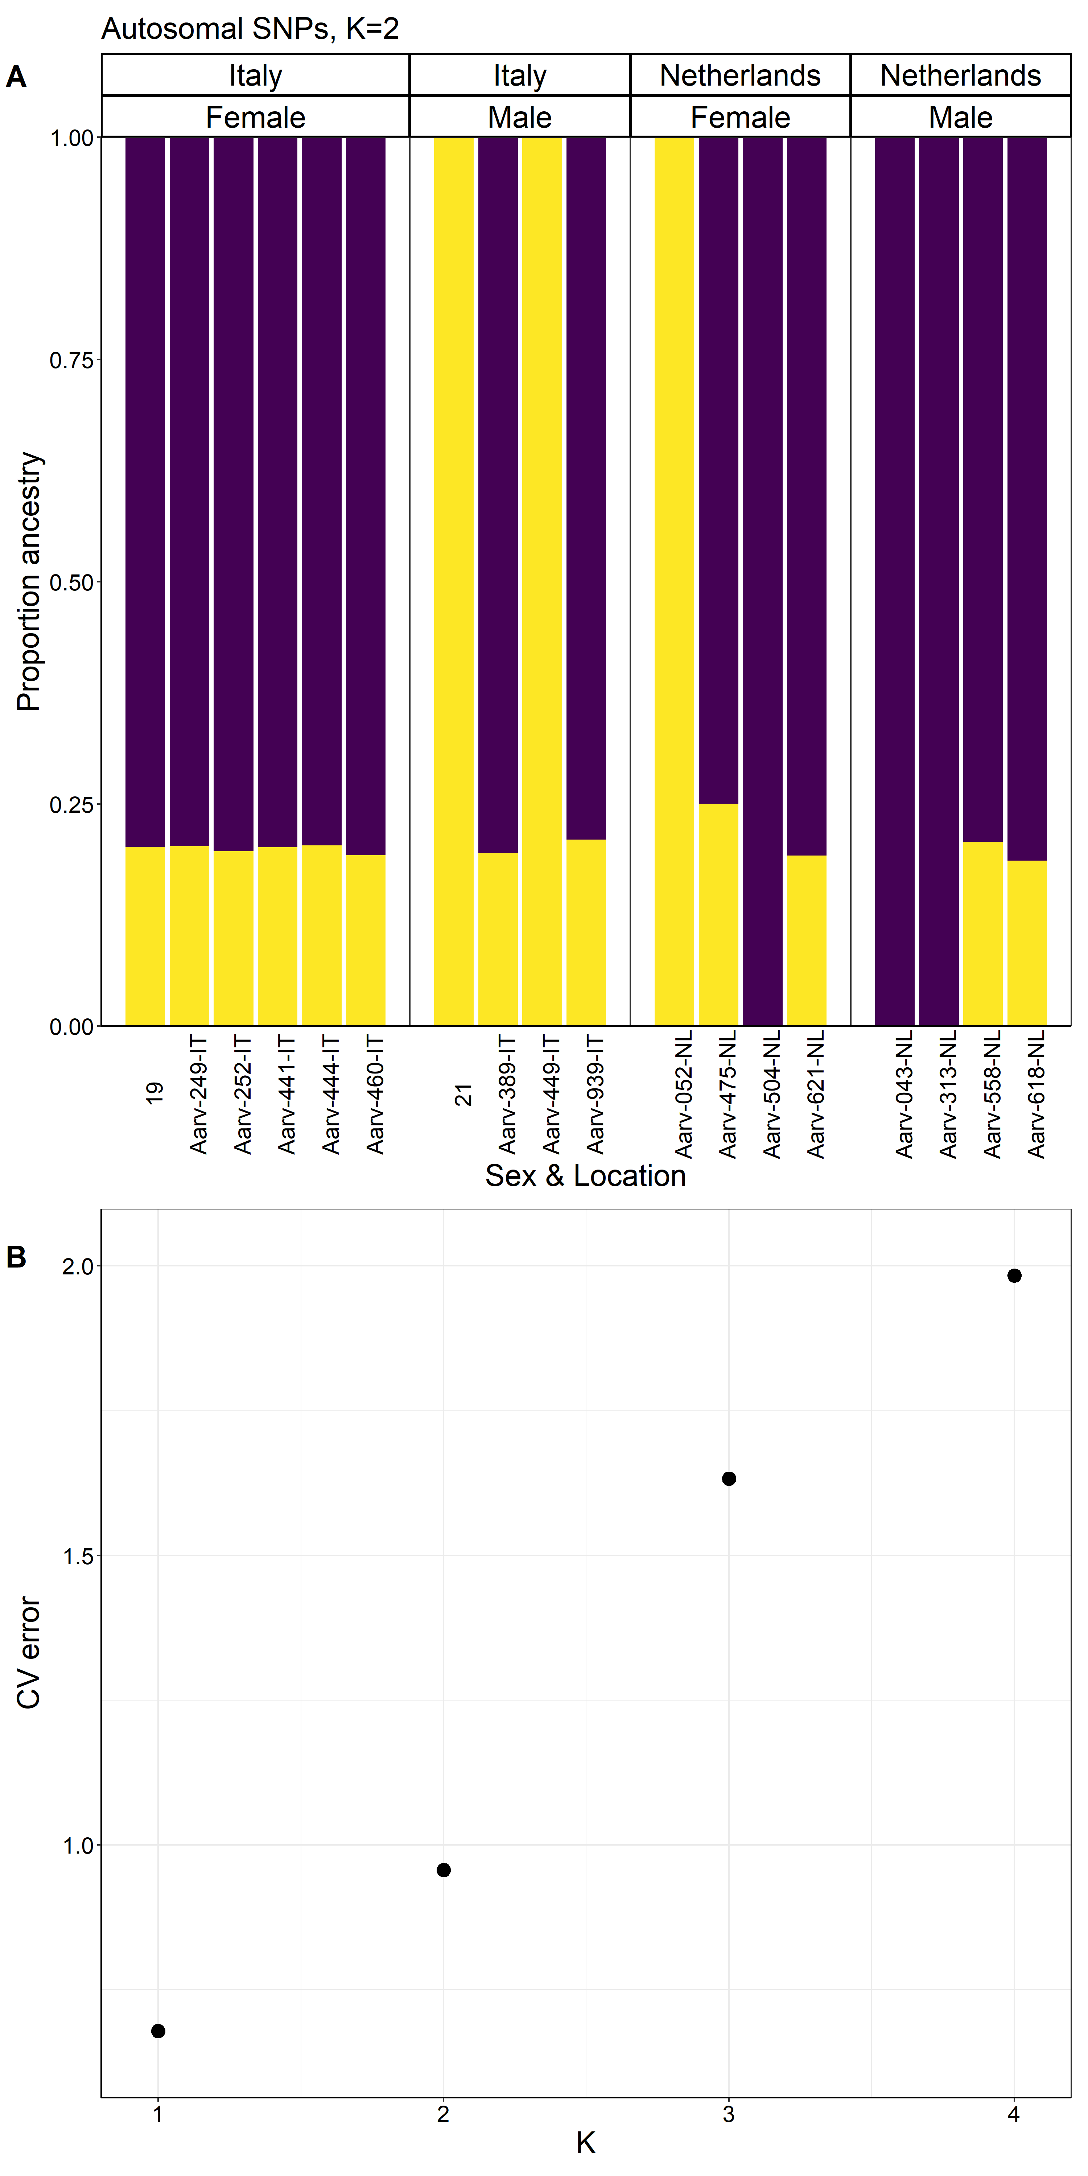
Figure S2 A) Ancestry proportions of skylark individuals under a model of K=2. B) CV error of models K=1-4. The analysis was based on biallelic SNPs from autosomes with a minor allele count of 2.

Figure S3: Linkage decay
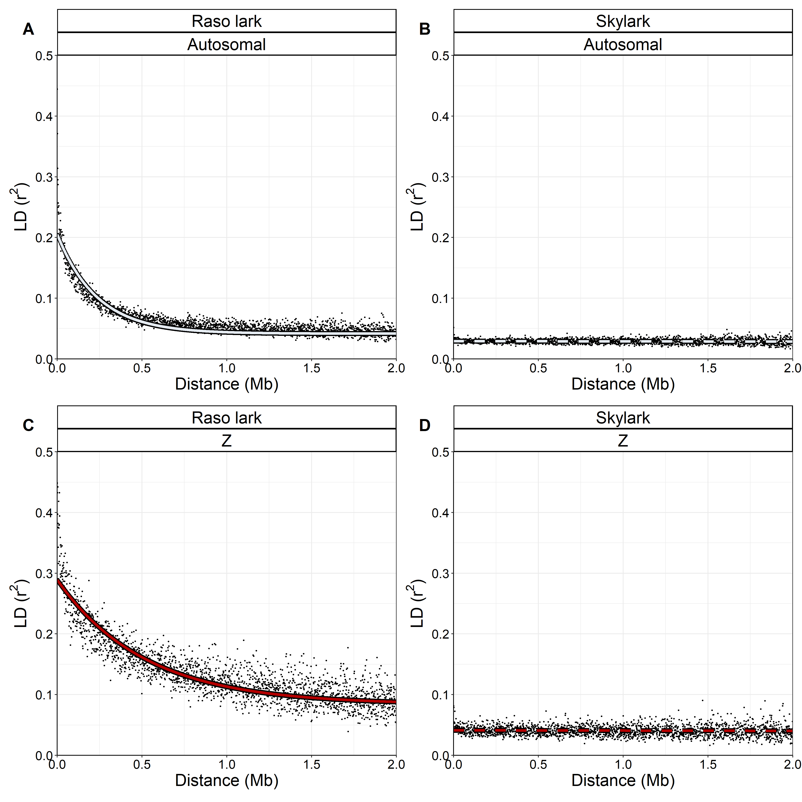
Figure S3 Fitted functions of linkage decay on autosomes and the Z chromosome. Points illustrate raw data averaged into 1 Kb bins, which the fitted function was based on.

Figure S4: Estimation of GERP scores
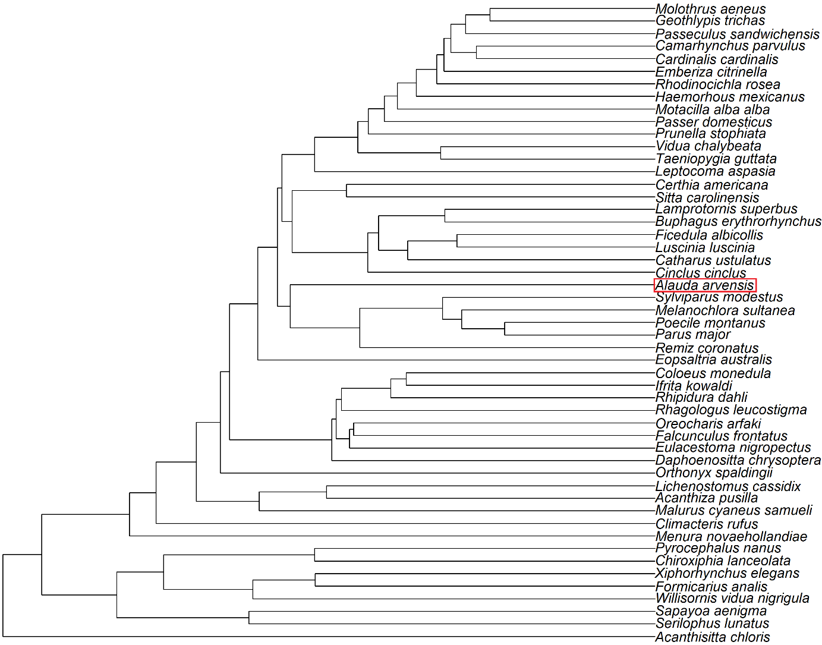
Figure S4 Phylogenetic tree with divergence times for species included in estimation of GERP scores. The skylark (Alauda arvensis) is framed in red. The tree is modified from Oliveros et al., (2019).

Figure S5-S7 Demographic inferences
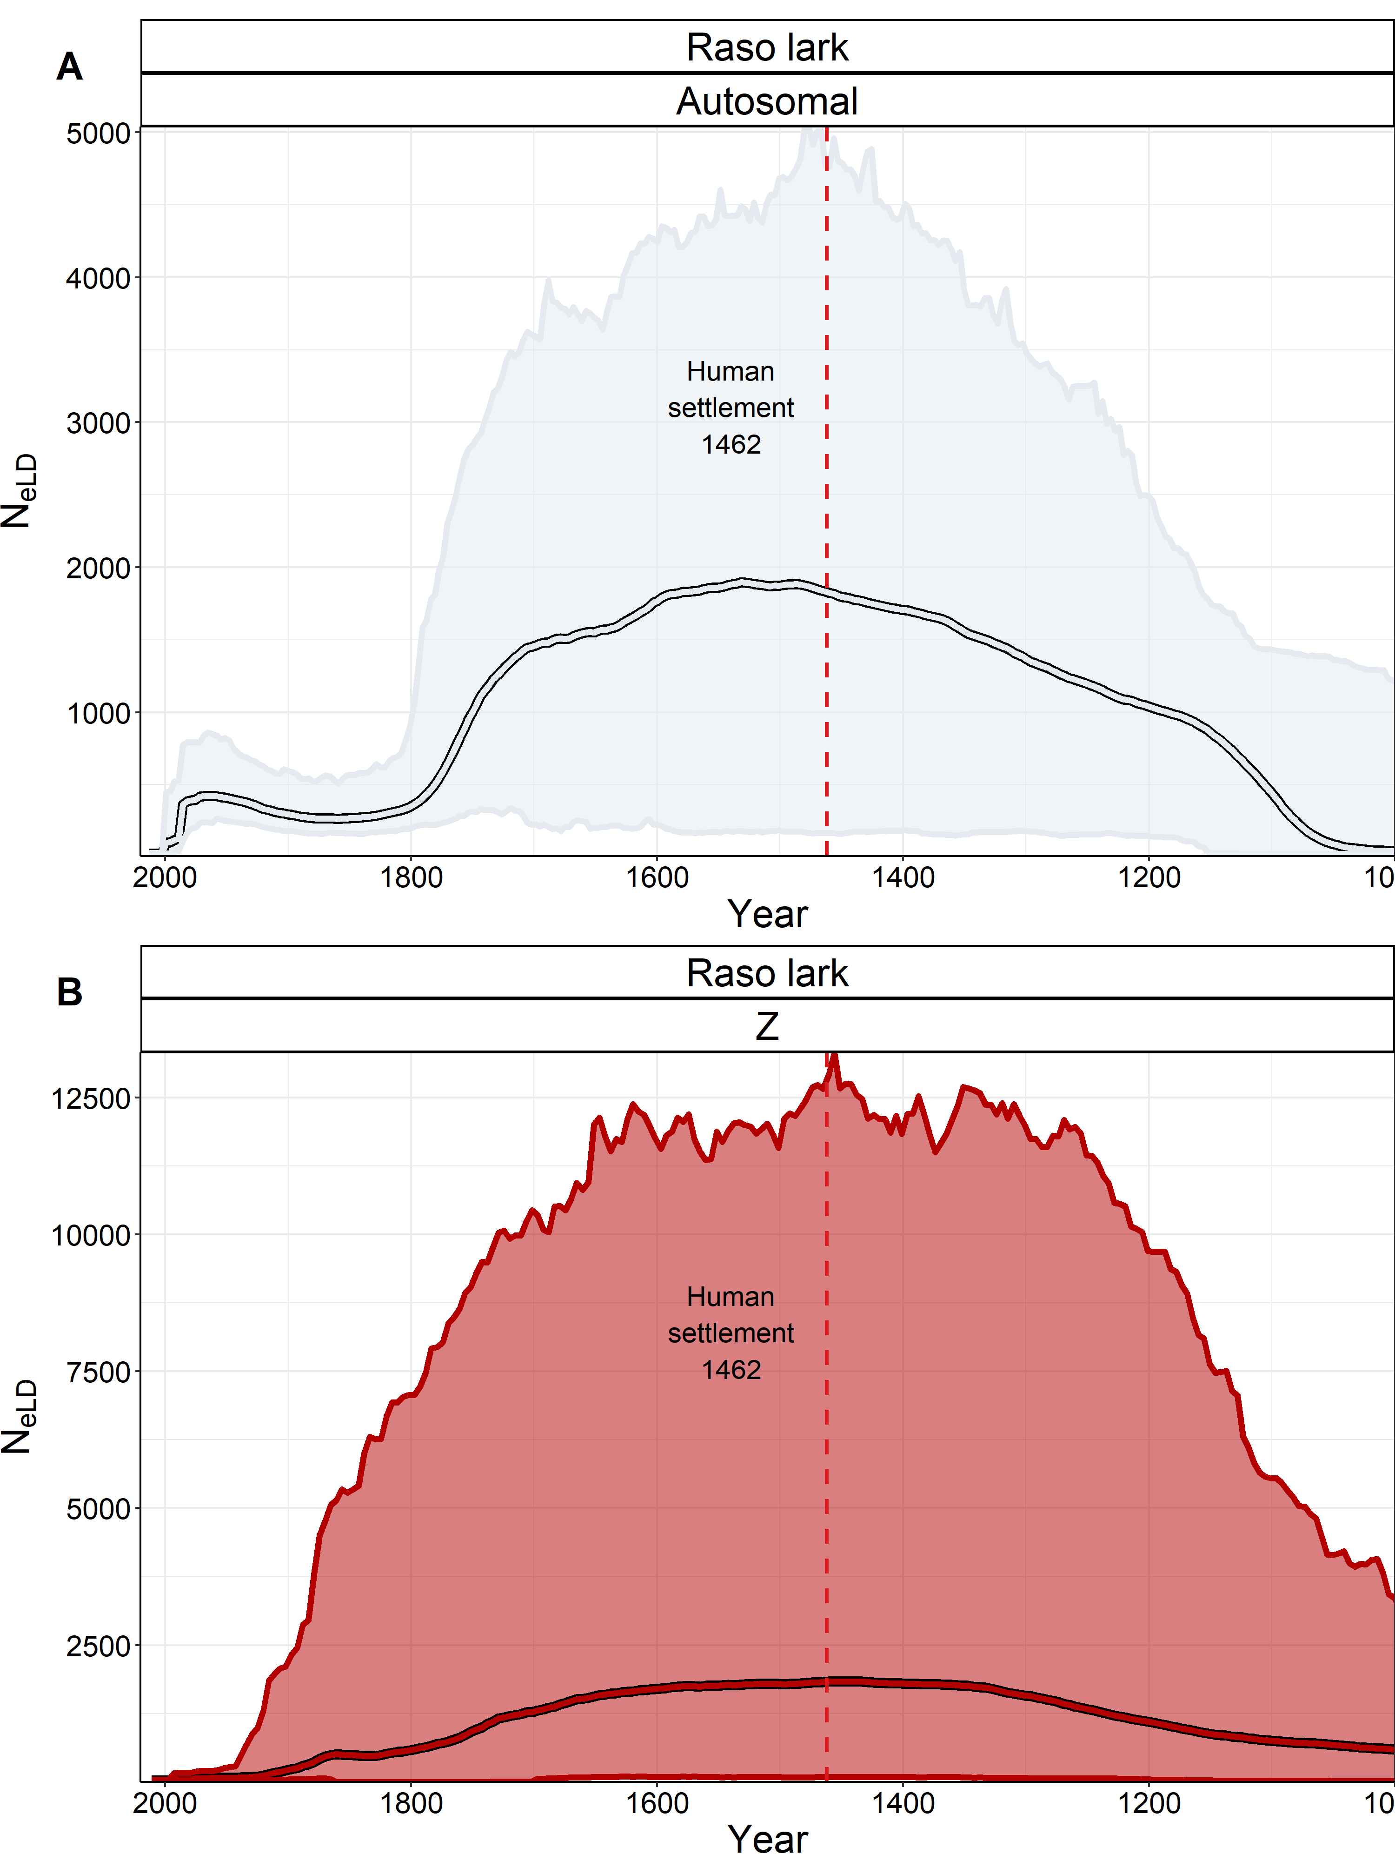
Figure S5 Estimated effective population size trajectories of the Raso lark autosomes and Z chromosome with GONE. The shaded area represents the 95 % confidence interval of 1 000 replicates, while the bordered line represents the average of those replicates. The red dashed line shows when the settlement of the Cape Verde islands began in 1462. Notice that the scale of the x-axis differs between the autosomes and the Z chromosome.
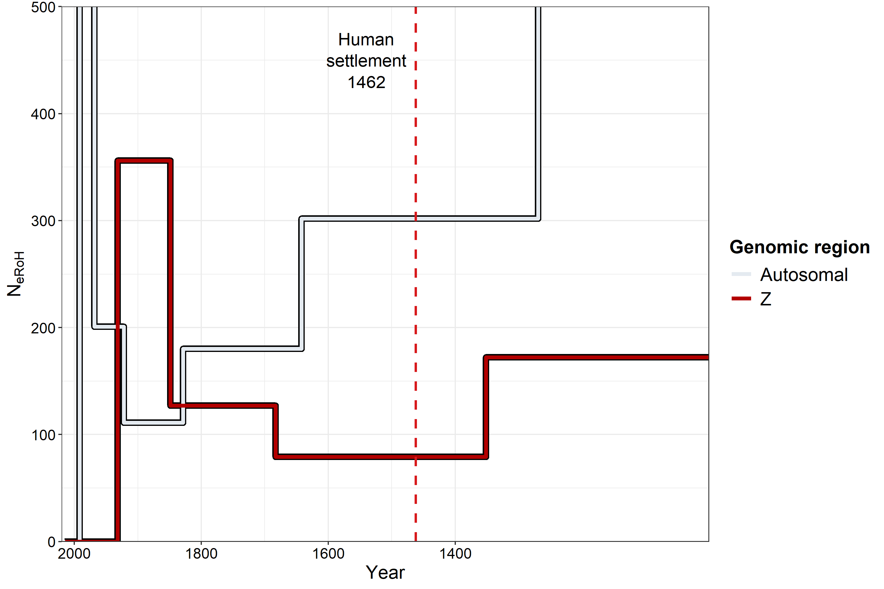
Figure S6 Estimated effective population size trajectories of the Raso lark autosomes and Z chromosome based on RoH. The red dashed line shows when the settlement of the Cape Verde islands began in 1462. Notice that recent autosomal population size peaks outside the range of the graph at ~5 900.

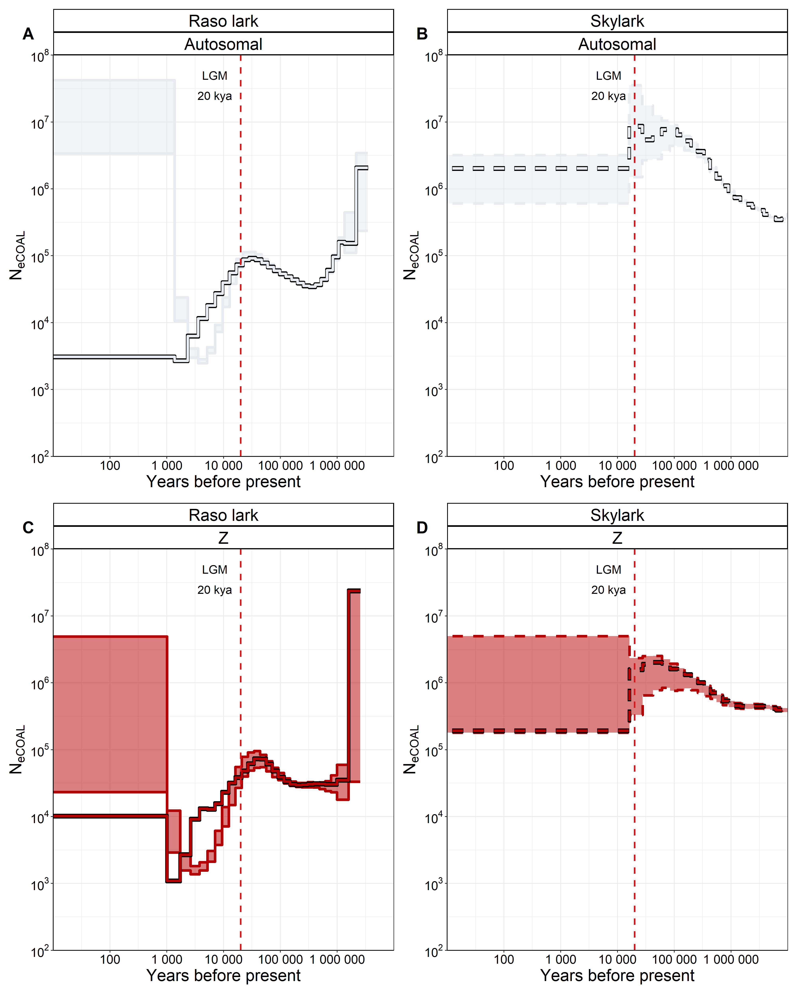
Figure S7 Estimated effective population size trajectories of the autosomes and the Z chromosome with MSMC2. The shaded area represents the 95 % confidence interval of 100 bootstraps, while the bordered line is inferred from the actual data. The red dashed line shows the Last Glacial Maximum ca 20 Kya.

Figure S8-S9 Functional genotype probability
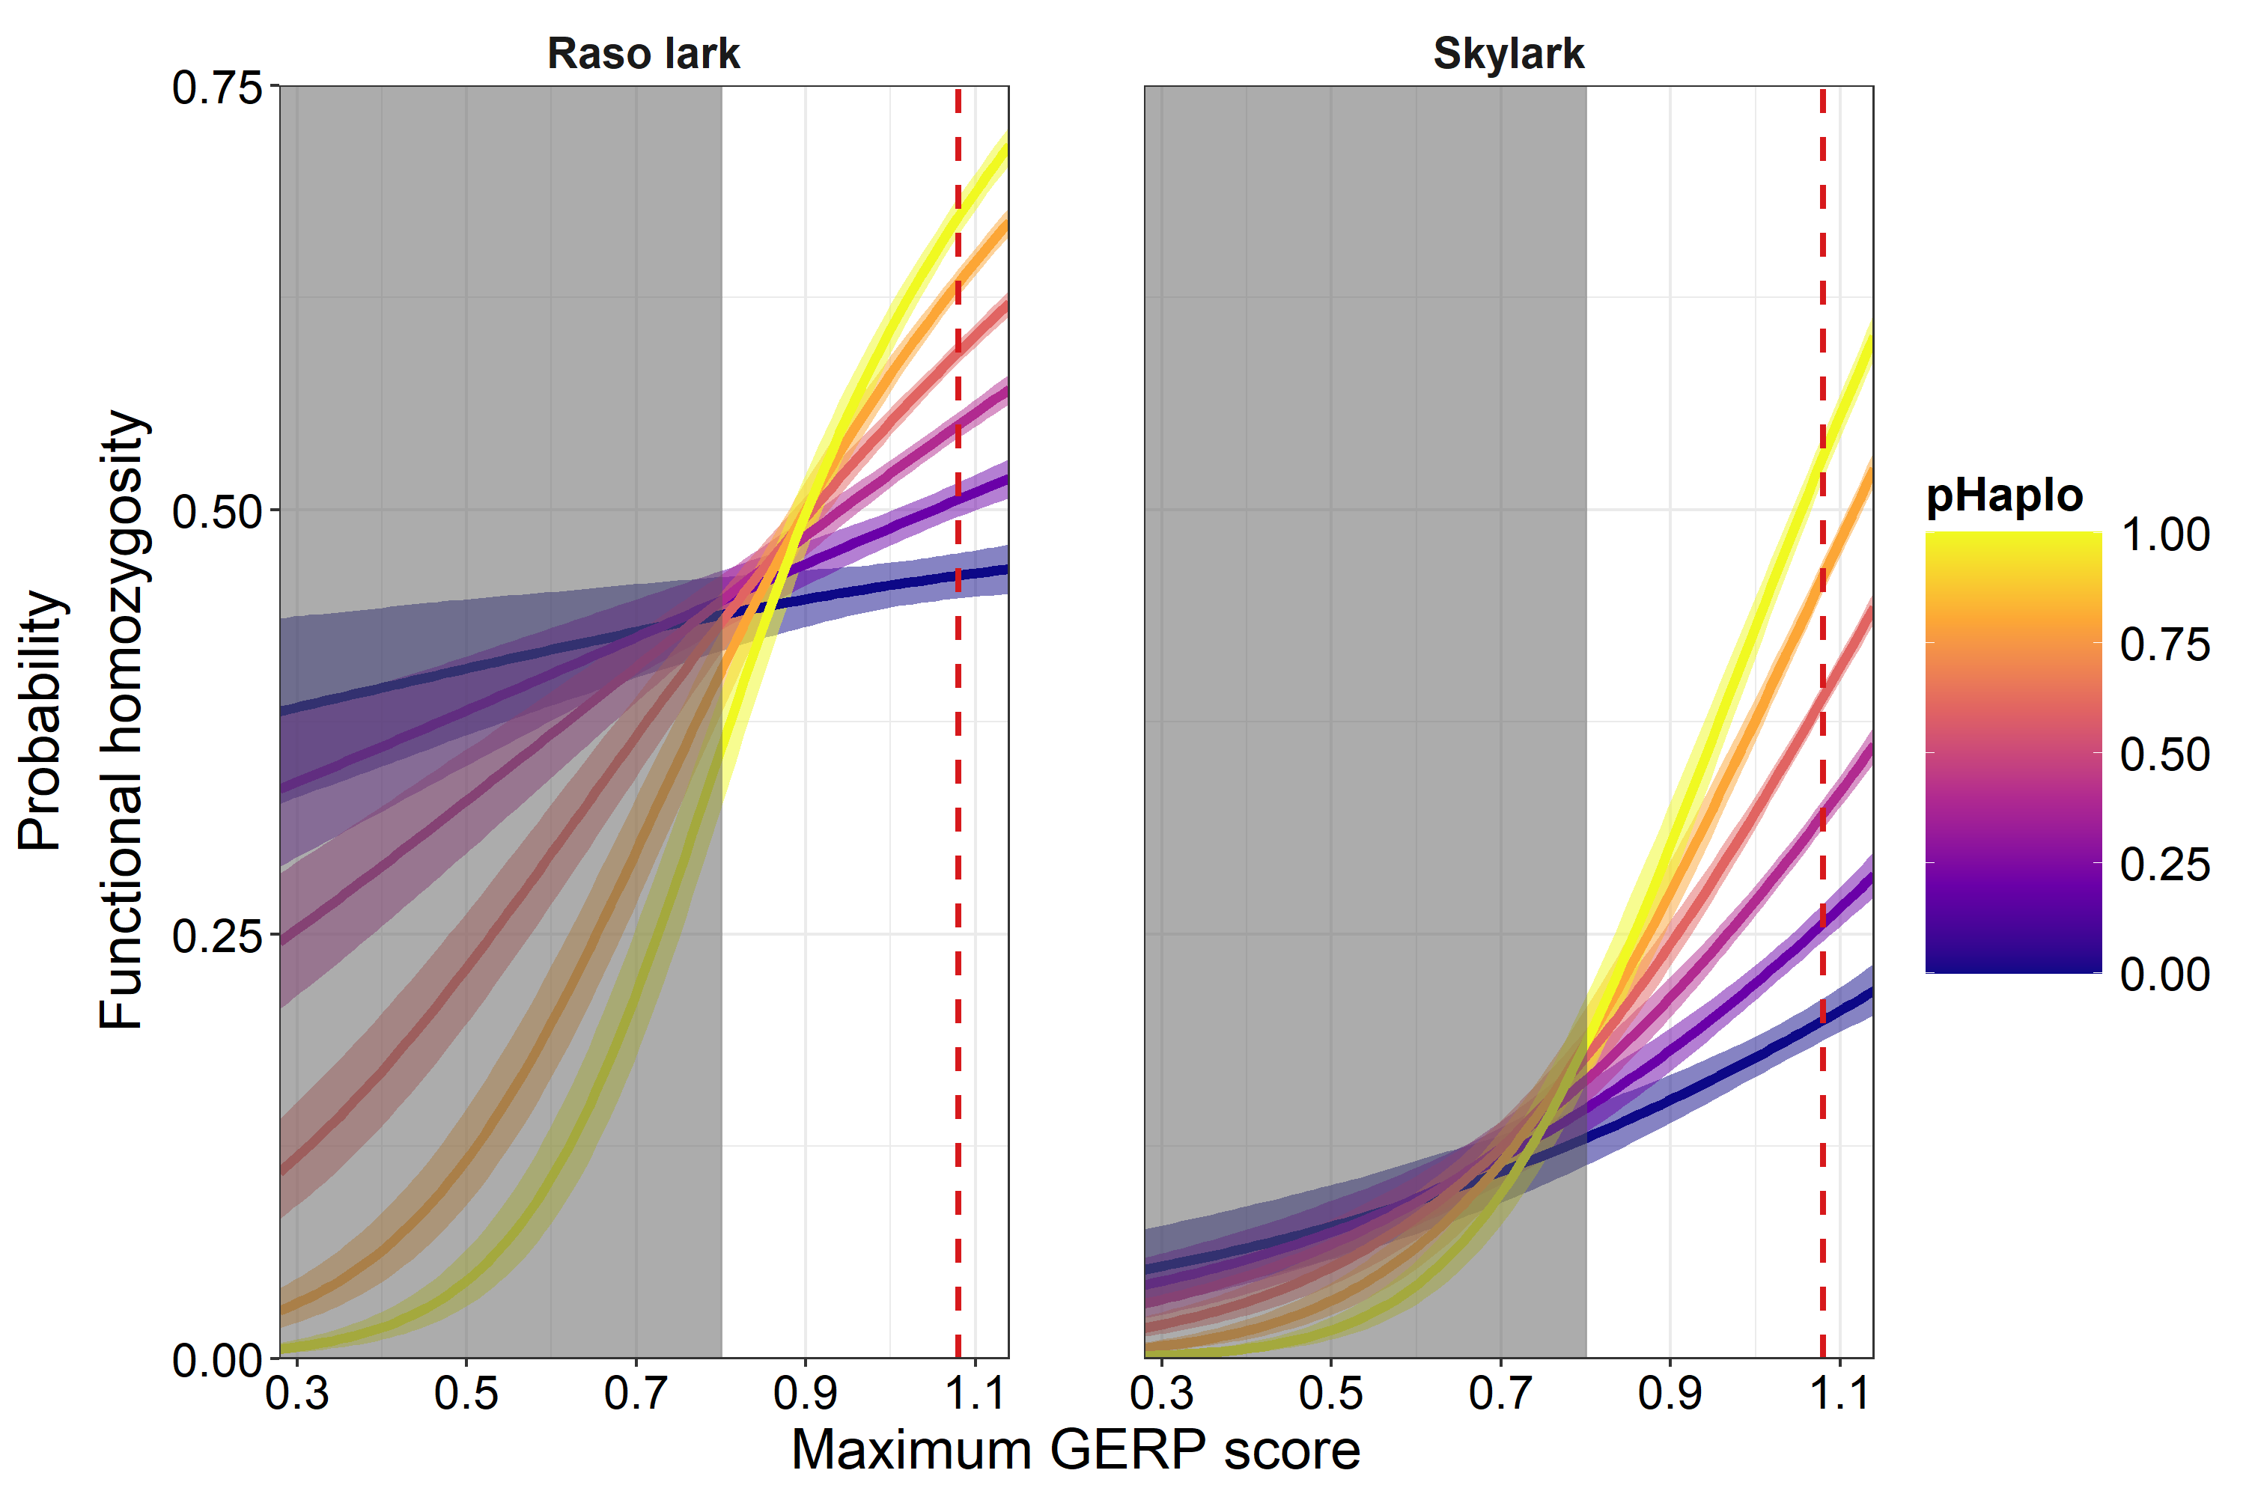
Figure S8 Probability of Functional homozygosity with 95 % credible intervals as a function of species, maximum GERP score, and haploinsufficiency. The shaded area corresponds to the lower 5 % percentile of maximum GERP score. The red dashed lines mark the median maximum GERP score.
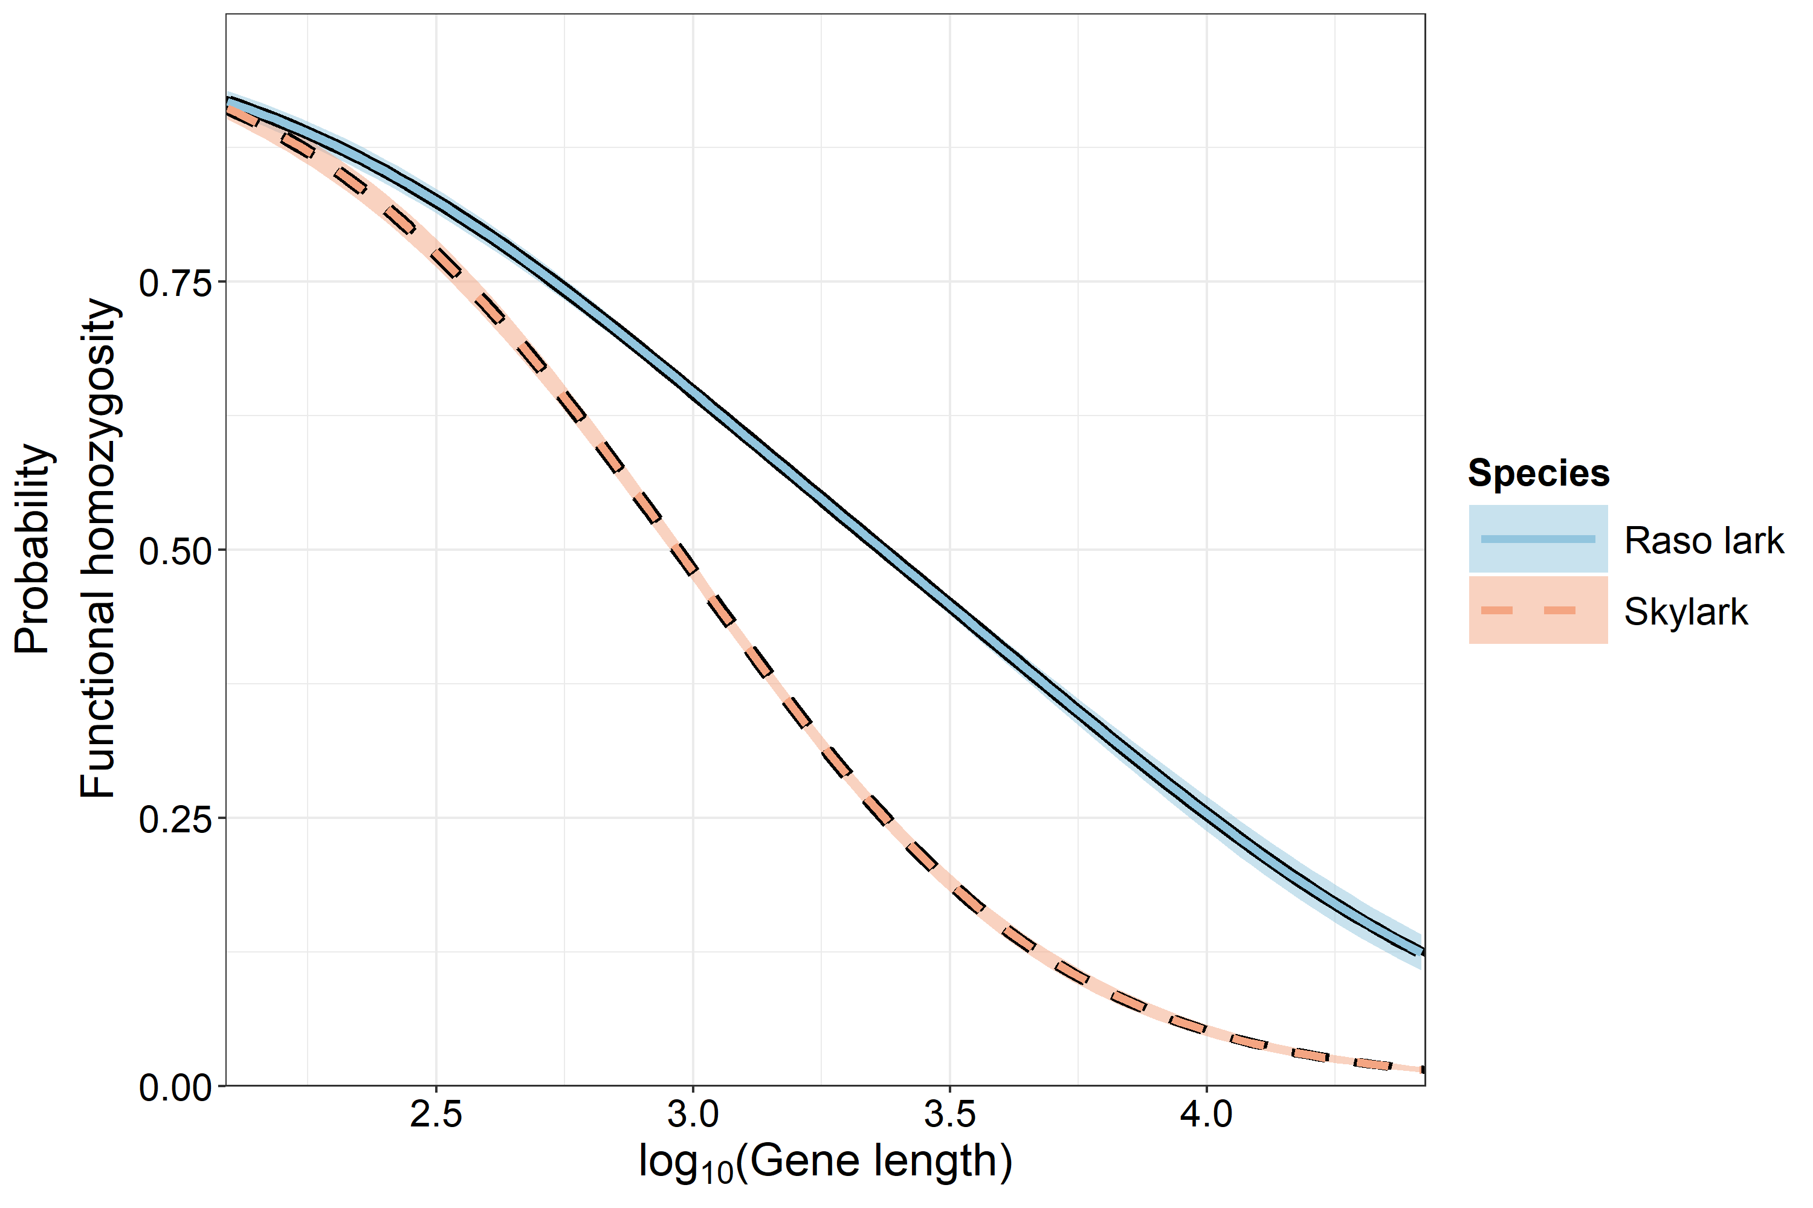
Figure S9 Probability of Functional homozygosity with 95 % credible intervals as a function of species, and gene length.

Figure S10-11 Z loss-of-function allele probability
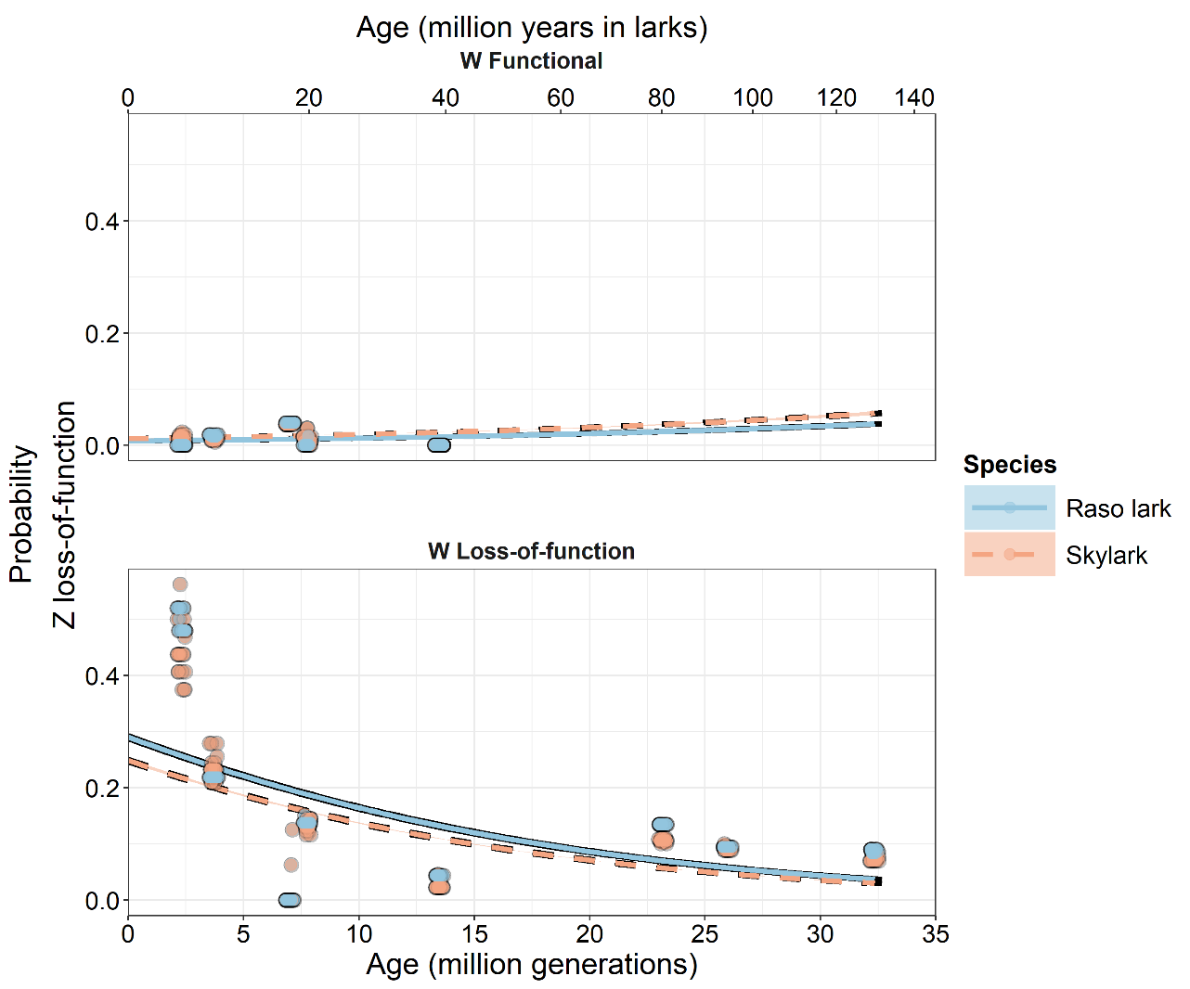
Figure S10 Probability of Z loss-of-function with 95 % confidence intervals as a function of fixed W functionality, species, and stratum age. Points represent raw proportions per individual and age, with horizontal jitter for visibility.
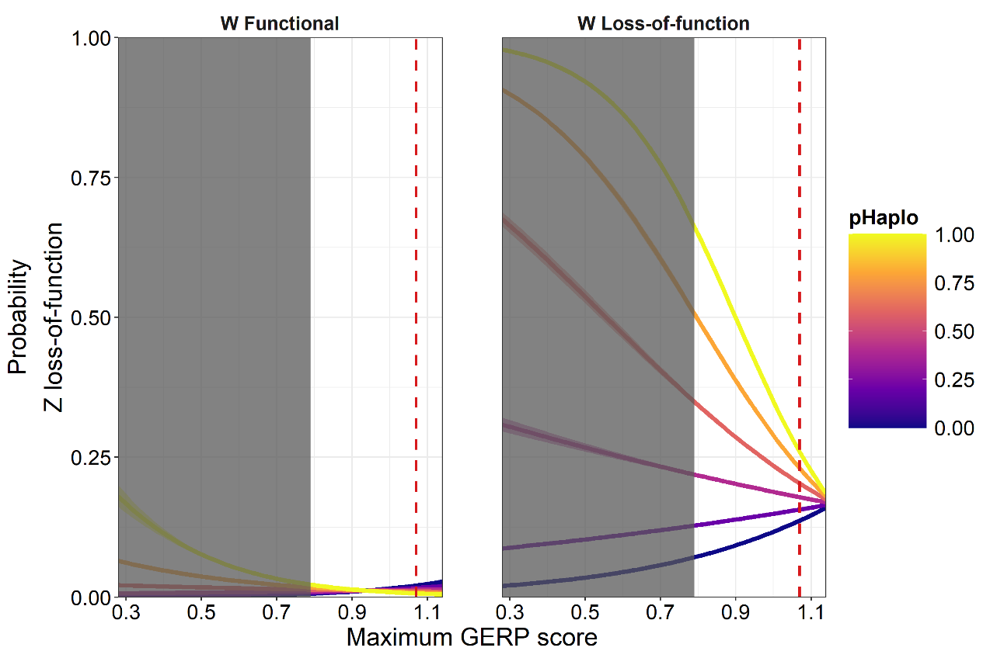
Figure S11 Probability of Z loss-of-function with 95 % confidence intervals as a function of fixed W functionality, maximum GERP score, and haploinsufficiency. The shaded area corresponds to the lower 5 % percentile of maximum GERP score. The red dashed lines mark the median maximum GERP score.

Figure S12-13 W guarding probability
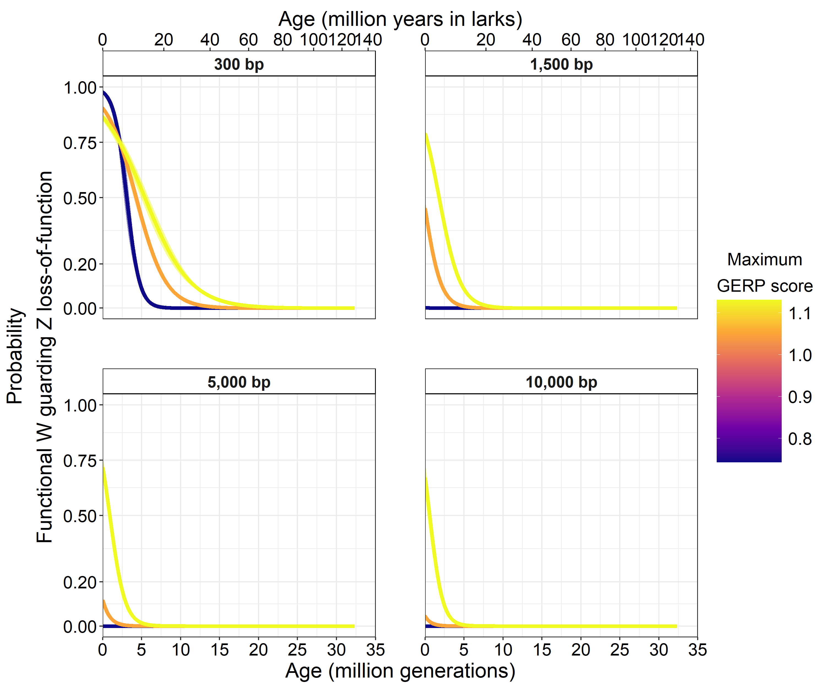
Figure S12 Probability of a functional W gametolog guarding a loss-of-function Z gametolog with 95 % confidence intervals as a function gene length, maximum GERP score, and stratum age. Maximum GERP scores is shown at 5 % , 50 % and 95 % percentile.
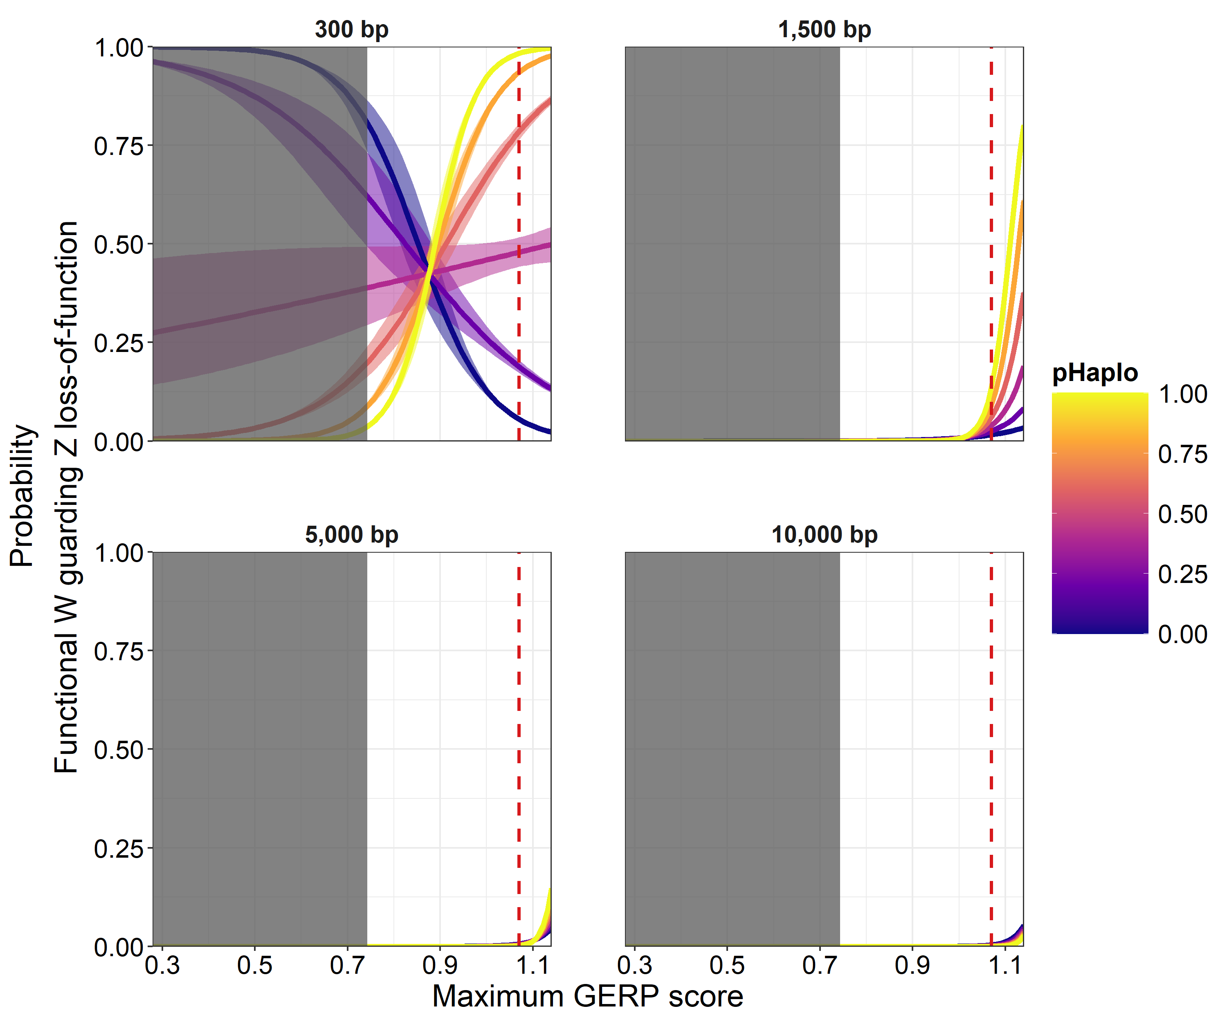
Figure S13 Probability of a functional W gametolog guarding a loss-of-function Z gametolog with 95 % confidence intervals as a function gene length, maximum GERP score, and haploinsufficiency. The shaded area corresponds to the lower 5 % percentile of maximum GERP score. The red dashed lines mark the median maximum GERP score.

